Version Maker

It is part of HIL Change Management System.

This VI sets the front panel title, keeps track of the versions of the executable, and registers the executable version in a file that can be used for updating the change registry.

## Setting Title:

It takes the file name in the following way. For

* the development mode, it gets the front panel title, and removes “.vi”.
* the run-time mode, it gets the file name, and removes “.exe”.

In the same folder as the application is stored, it creates/opens ‘filename’.ini. Under the section “Information”, it writes the filename for the key “File Name” if the key “Original” is not True.

See the below example

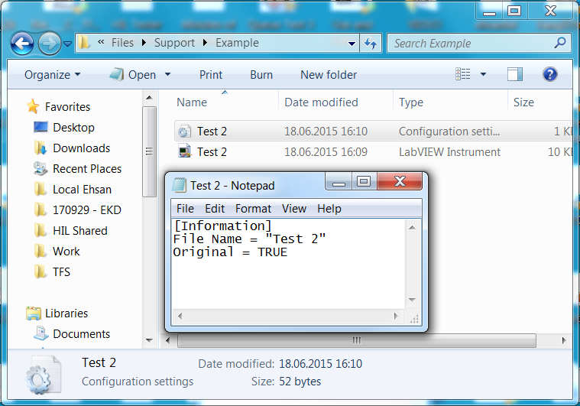

It sets the title of the application in the title bar in the following way:

* the development mode, the front panel title is <<*filename*.vi>>.
* the run-time mode, the title is << *filename* – build version >>.

## Run Version History:

It keeps track of versions of executables that are run.

This VI creates << *filename –* Version History.txt >> in the specified folder, and writes down the version of the running executable marked with date and time.

Note: There is not version history for development mode.

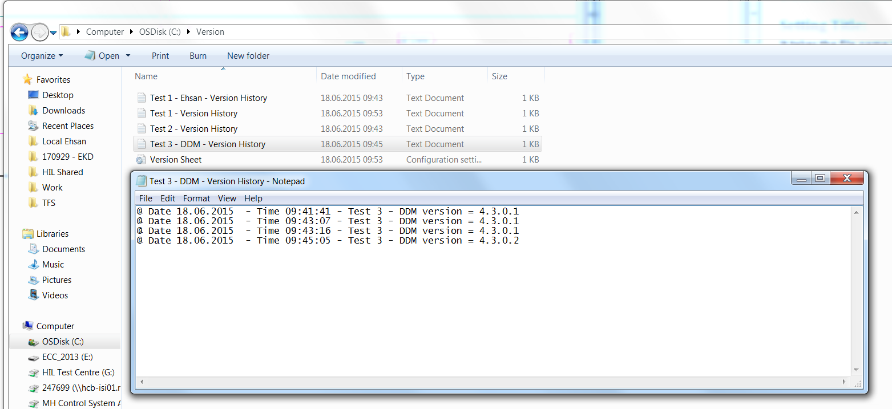

Figure Example of Run Version History in the specified folder for the executable "Test 3 - DDM"

## Executable Version Registry:

It writes down the version of the running executable file in a configuration file.

It opens (if does not exists, it creates) the configuration file based on the inputs (Folder Path and file name). Under specified section, for the key as the file name, it writes the version number as the value.

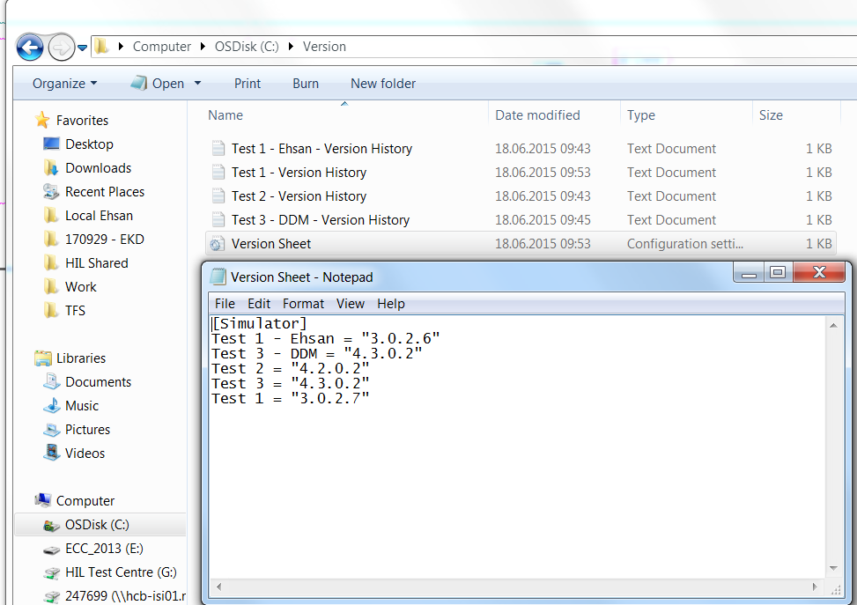

Figure Example of Version Sheet collecting the running version of executable files

## Important Points

* The VI name and the executable name shall be identical.
* If the instances of executable are run under different configurations (for example, SimbaProfibusIO Interface for different PLCs), take the following steps: